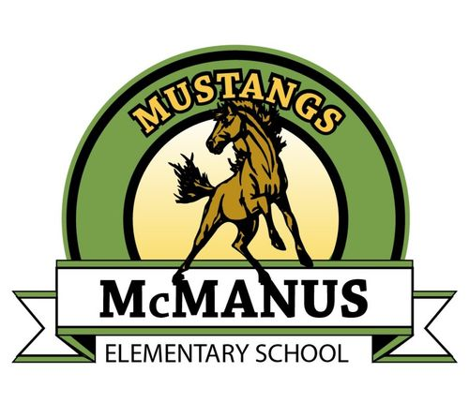
Positive Behavior Interventions and Supports Handbook 2023-2024

What are Positive Behavior Interventions and Supports?
Positive Behavior Interventions and Supports (PBIS) is an approach to supporting students to be successful in schools. PBIS was developed from research in the fields of behavior theory and effective instruction. PBIS supports all students through intervention ranging from a school- wide system to a system for developing individualized plans for specific students.
McManus Expectations Matrix
Area / Setting | Safe | Respectful | Responsible
Walkways | - Always walk.  - Keep hands and feet to yourself.  - Stay on the walkway. | - Walk quietly.  - Stay in your line order.  - Respect personal space. | - Be safe and patient.  - Carry playground equipment.
Playground | - Kick the playground balls on the grass only.  - Stay in supervised areas.  - Please use equipment appropriately and with respect.  - Keep hands, feet, and objects to yourself.  - Running on the field is acceptable, weather permitting.  - Walk on the blacktop and the playground. | - Have all games open to everyone.  - Play fair.  - Be respectful to our equipment. | - Freeze at the sound of the bell.  - Walk to your class line after the whistle blows.  - Keep personal play equipment and toys at home.  - Eat snacks at lunch tables and pick up your snack after.
Cafeteria/Eating Areas | - Walk.  - Keep all food to yourself.  - Keep hands and feet to yourself while you are in line.  - Wait patiently in line.  - Stay seated.  - Make healthy food/drink choices. | - Use your manners.  - Kindly allow anyone to sit next to you. | - Use quiet voices.  - Clean up your area.  - Stack your tray neatly.
Bathrooms | - Keep hands and feet to yourself.  - Walk.  - Keep the water in the sink.  - Keep food out. | - Use the restroom responsibly and then exit.  - Give privacy to others.  - Use a quiet voice. | - Wash your hands.  - Clean up after yourself.  - Return to class quickly.  - Report any issues to McManus staff.
Office Area | - Walk.  - Keep hands and feet to yourself.  - Sit on the bench or chairs. | - Enter quietly.  - Greet office staff.  - Wait to be welcomed.  - Be polite. | - Blue slip-have permission and a purpose for being there.(*Radio acceptable)  - Wait your turn.  - Clean up after yourself when you leave.
Loading Zones, Arrival and Dismissal | - Keep hands and feet to yourself.  - Walk.  - Stay in supervised areas.  - Walk bike and carry scooters and skateboards on campus and perimeter of school. | - Use appropriate voice and language.  - Follow the directions of the adult in charge. | - Follow the rules and remind others to do the same.  - Be in control of your belongings.
Library | - Sit on bottoms  - Walk at all times | - Use quiet voices | - Put books away correctly  - Return/renew books weekly
Special Events and Assemblies | - Keep all hands, feet and objects to self | - Remove hat  - Clap politely  - Respond quickly to quiet signals | - Sit on bottom in assigned area

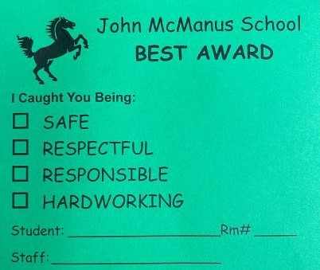
Behavior Management Systems Tier 1 in place at McManusExamples include:
-Behavior Clip Charts, Classroom Specific Rules Posted, McManus Expectations/Rules Posted, Fix-It-Tickets
Positive Incentives: Prize Boxes, Green Slips, McManus Store (The McManus Store is sponsored and run by our PTA) , Awards Assemblies acknowledging student behaviors

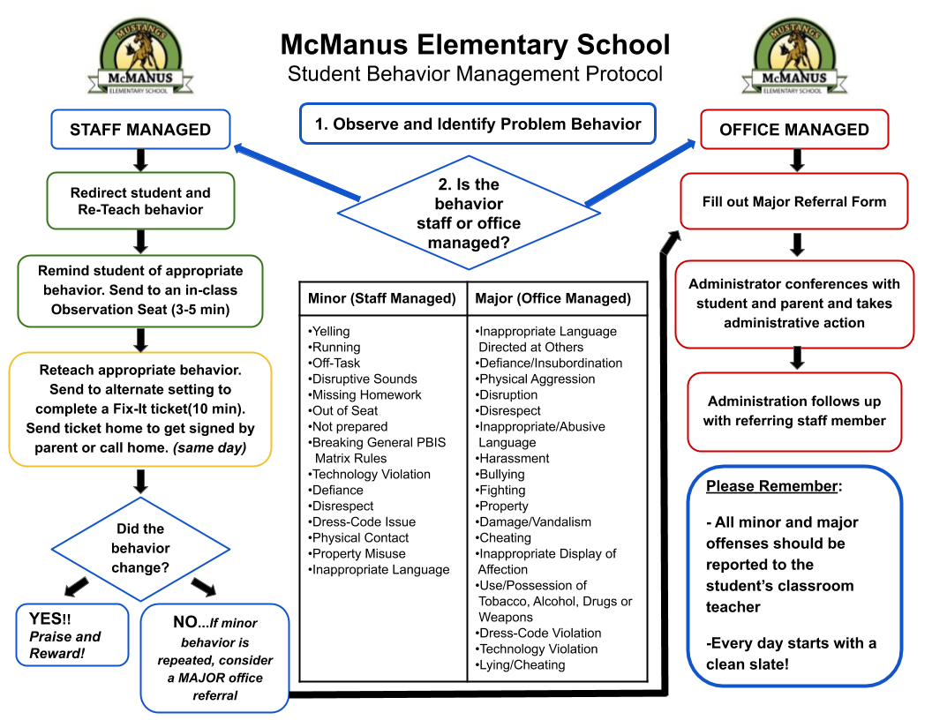
(Fix it ticket examples on page 3 below)
Restorative Justice Questions (McManus Conflict Resolution Questions)
- What happened?
- What were you thinking at the time?
- What have you thought about since?
- Who has been affected by what you have done? In what way?
- What do you think you need to do to make things right?

