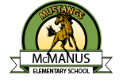

John McManus School Site Council Meeting Agenda

Thursday, May 2, 2024

1. Review Budget for 24-25
2. Recommend Site Council approval of SPSA to CUSD Board
3. Review and revise priority of needs based on data